Customer Name: Phone #: Date:

Customer Address:
City: State/Prov.: ZIP CODE:

Dealer Company Name:

Dealer Company Address:

Dealer Contact: Survey Location:

Boat Description: HIN#

Engine Brand/model: Engine Center to Center Distance

Engine(s) Rotation & Position ________________

Tach Input: NMEA2000 Engine Gateway Converter to NMEA2000 Analog Tach Input

Center Engine(s) Drop __________Center engine drop greater than 3” needs to be reviewed by engineering

Autopilot Raymarine EV2 Garmin Reactor Simrad SG05
If not Garmin Reactor, Raymarine EV2 or SIMRAD SG05, customer will need to upgrade.

Helm Type Front Mount Rear Mount Classic Tilt Sport Tilt

Color Display Location: Note: if located in electronics box extensions might be needed. (CM22401, CM204xx, CM100xx)

SmartCylinders Standard Tournament (Will not fit Yamaha F300)
Inverted Plates (BRP & Suzuki) Confirm splashwell clearance Confirm full-tilt clearance Confirm bulkhead placement

Steering Pumps Location: ___________ (within 3’ of PCM) Floor mount Wall mount

Pump Outlet fittings Horizontal and Vertical Position (comes with pump) ORB Fitting Needed?

Hydraulic Bulkhead Type Single Black Single Stainless Dual Stainless

Hydraulic Hose Layout

Distance from Port pump to Port cylinder Round up to the nearest foot increment

Distance from Starboard pump to Starboard cylinder Round up to the nearest foot increment
Harness Layout Main Station

Distance from Helm to PCM (CM204xx) 3 feet 6 feet 12 feet 18 feet 24 feet 30 feet 36 feet Other _____

Distance from Joystick to Helm (CM204xx) None 3 feet 6 feet 12 feet 18 feet 24 feet 30 feet 36 feet Other _____

Distance from PCM to SmartStick (18Ft standard) ___________port ___________stbd Extensions required Y/N 6 feet 12 feet 18 feet

MST System Only
Distance from Actuators to Private Network (CM100xx) 3 feet 6 feet 9 feet 12 feet 16 feet 20 feet 30 feet
Mechanical Cable Lengths ___________ port ___________ starboard

Second Station Yes/No

Helm Type Front Mount Rear Mount Classic Tilt Sport Tilt

Color Display Yes/No (if no, then buzzer kit is required)

Joystick Yes/No

Harness Layout Second Station

Distance from Helm 2 to PCM (CM204xx) 12 feet 18 feet 24 feet 30 feet 36 feet Other _____

Distance from Helm 2 to Lower Station 12 feet 18 feet 24 feet 30 feet 36 feet Other _____

Distance from Joystick 2 to Helm 2 3 feet 6 feet 12 feet

Fabrication (Not by SeaStar) Helm mounting plate Joystick mounting plate Other

Notes:

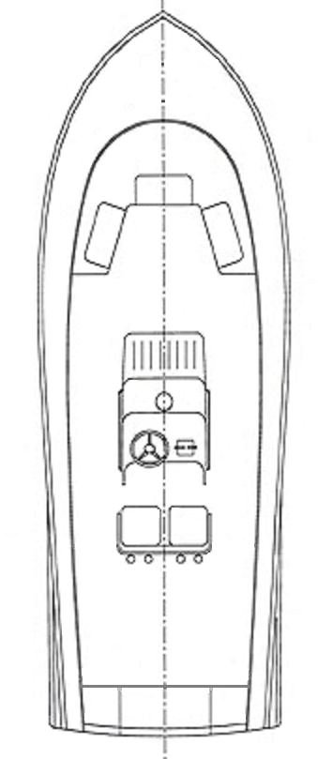
Layout Sketch

